
How to use this module:

MODULE 4:

Electric Motors & Drives
These modules are designed to build upon each other, culminating in a final activity. Resources like handouts, assessments, and web links are provided, but you are encouraged to find additional materials. Example curriculum alignments for Ohio Learning Standards and NGSS are included; use the provided links to explore and select the most relevant standards for your needs.

Some modules may require equipment purchases. Recommendations are provided, but these are not endorsements. Conduct your own research before purchasing or using any external resources.

LIABILITY RELEASE: This curriculum is provided "as is," without warranties. Partnership for Innovation in Education (PIE) is not liable for any damage arising from its use, including equipment purchases or reliance on external resources.

MODULE 4 OVERVIEW
This module offers a thorough investigation into electric motors and their use in electric vehicles (EVs), covering key aspects such as fundamental principles, different motor types, control systems, and performance considerations. The topics explored in this 5-day module include:
- Fundamental principles of electromagnetism and motor operation
- Advantages of electric motors in EV propulsion
- Categorization of different motor types
- Examination of DC motors (brushed and brushless variants) and their control
- Detailed analysis of AC motors (induction and synchronous types)
- Comparison between AC and DC motors
- Motor control and drive systems, including: Inverters, Controllers, Sensors, Power electronics, Energy management & Regenerative braking
- Efficiency and performance considerations
- Introduction to CAD modeling of motor components
- Exploration of the environmental benefits of electric motors

MAIN LEARNING OBJECTIVES
- Students will be able to differentiate between various types of electric motors, including brushed and brushless DC motors, and AC induction and synchronous motors, outlining their operational principles, key characteristics, and typical applications within the EV industry.
- Students will be able to identify and describe the key components of electric motor control systems in EVs, such as inverters, controllers, and sensors, and explain the function of drive systems, including power electronics and regenerative braking.
- Students will be able to analyze factors that influence the efficiency and performance of electric motors and begin to apply basic CAD software skills to model simple electric motor components.

CURRICULUM ALIGNMENT
Ohio Learning Standards
- P.EM.1: Explain the relationship between electric and magnetic fields and their applications in technological devices.
- 9-12.TT.01: Analyze the evolution of transportation and its impact on society and the environment.
- 9-12.EPT.02: Investigate and evaluate various energy conversion systems and their efficiencies.
- Ohio Technology Standards:
  - Empowered Learner: 9-12.KC.3.a.
  - Digital Citizen: 9-12.DC.2.c.
  - Knowledge Constructor: 9-12.KC.3.c
  - Innovative Designer: 9-12.ID.4.d.
  - Computational Thinker: 9-12.CT.5.c.
  - Creative Communicator: 9-12.CT.5.c.
  - Global Collaborator: 9-12.GC.7.c.
NGSS Standards
- HS-PS2-3: Apply scientific and engineering ideas to design, evaluate, and refine a device that minimizes the force on a macroscopic object during a collision.
- HS-PS3-3: Design, build, and refine a device that works within given constraints to convert one form of energy into another form of energy.
- HS-ETS1-1: Analyze a major global challenge to specify qualitative and quantitative criteria and constraints for solutions that account for societal needs and wants.

Career Connections
Below are some resources and information relevant to careers pertaining to the curriculum in this module.
- Video: Electrical Design Engineer Intern: Jacob K. - KEB America Careers

Electric Motor Design Engineer:
- Conceiving and designing new electric motor models for EVs.
- Applying principles of electromagnetism and motor operation.
- Selecting appropriate motor types (AC, DC, brushed, brushless, induction, synchronous) based on application requirements.
- Considering factors like efficiency, power density, and thermal management in the design process.
- Utilizing CAD software to create and analyze motor component designs.
- Developing and overseeing the testing and validation of motor prototypes.
EV Powertrain Engineer:
- Designing and integrating the electric motor with other powertrain components (inverter, controller, battery).
- Developing and implementing motor control algorithms and strategies.
- Working with power electronics and energy management systems.
- Implementing and optimizing regenerative braking systems.
- Ensuring the overall efficiency and performance of the EV's propulsion system.
- Troubleshooting and resolving issues within the powertrain system.
EV Battery Technician / Assembler:
- Assembling, testing, and repairing EV battery packs.
- Working with individual battery cells, modules, and battery management systems.
- Following strict manufacturing and safety procedures.
- Using specialized tools and equipment for battery handling and testing.
- Understanding the chemical and electrical principles of battery operation.
Note: These roles can range from entry-level assembly positions that require on-the-job training to more technical roles that may benefit from vocational training or an associate's degree in a related field.
Lesson Overview – Day 1: Introduction to Electric Motors and EV Propulsion
This introductory lesson establishes the foundational understanding of electric motors and their critical role in electric vehicle propulsion. Students will explore the basic principles of electromagnetism that underpin motor operation through a hands-on building activity and relate this to video demonstrations of EV superiority and drive systems. Furthermore, through group research comparing EVs to internal combustion engine vehicles, including a quantitative analysis of energy loss, students will grasp the advantages and necessity of electric motors in this context and gain an initial overview of the different types of electric motors used in the industry.
*Please review all resource links and appendix resources prior to starting lesson activity.

Lesson Learning Objectives | Lesson Resources
Students can explain the basic principles of electromagnetism.  Students understand the importance of electric motors in EVs.  Students can identify the general categories of electric motors. | Video: Why Electric Vehicles Are Better Than All Cars  Science Buddies: https://www.sciencebuddies.org/science-fair-projects/project-ideas/Elec_p051/electricity-electronics/build-a-simple-electric-motor  Video: How an Electric Car Works? Its Parts & Functions (Explained)
Lesson Time | Lesson Materials
45 Minutes | Tablets/Laptops  Internet Access  Science Buddies Electromagnetic Motor Materials & Handout

Lesson Introduction
Today, we start learning about electric motors, which are key to how electric vehicles (EVs) move. You'll learn the basics of how electricity and magnets work together to make motors spin. We'll see why EVs use electric motors and what benefits they have over regular gas cars. You'll also get a first look at the different kinds of electric motors used in EVs. We'll watch videos, build a simple motor to see how it works, and in groups, you'll figure out why EVs are better by comparing them to gas cars and even calculating how much energy each type loses. By the end of today, you should be able to explain how electric motors work, why EVs need them, and name the main types of these motors.

Lesson Activity/Presentation

Introduction
- Watch the video "Why Electric Vehicles Are Better Than All Cars."
- Discuss initial thoughts and questions about EVs.
- Watch next video: “How an Electric Car Works? Its Parts & Functions.”
Electromagnetic Motor Demonstration (10 minutes)
- Build a simple electromagnetic motor following the instructions on the Science Buddies website.
- Explanation of Parts:
  - Battery: Provides the electrical energy.
  - Wire: Conducts the electricity, forming a loop.
  - Magnet: Creates a magnetic field.
  - Paperclip/Support: Holds the wire loop and acts as a contact point.
- How it Works: The electric current flowing through the wire loop creates a magnetic field. This interacts with the magnet's magnetic field, causing the loop to rotate. This is the basic principle behind how electric motors in EVs work.
- Relate this demonstration to the video "Introduction to electric vehicle drive systems." and "How an Electric Car Works? Its Parts & Functions (Explained)"
Energy Loss Calculation (25 minutes)
- Divide students into groups. Each group is assigned to compare an EV model with its ICE counterpart:
  - Hyundai Kona/ Kona Electric
  - Ford F-150/ F-150 Lightning
  - BMW i4/ BMW 4 Series Gran Coupe
  - Volvo CX40/ CX40 Recharge (or C40 Recharge)
  - Mini Cooper/ Mini Cooper Electric
- Groups research and calculate the energy loss (or efficiency) in both the EV and ICE models. This might involve comparing fuel consumption/electricity usage over a set distance.
Presentations and Class Discussion (10 minutes)
- Each group presents their findings, comparing and contrasting the energy efficiency and other advantages/disadvantages of their assigned EV and ICE models.
- Facilitate a class discussion to compare the findings across all groups and draw conclusions about the overall benefits and drawbacks of EVs.

Lesson Overview – Day 2: DC Motors and Their Applications
This lesson covers the operation, types, advantages, disadvantages, and basic control of Direct Current (DC) motors. DC motors operate through the interaction of magnetic fields created by the stator and rotor, with the commutator and brushes (in brushed motors) ensuring continuous rotation. The two main types are brushed and brushless DC motors. Brushed motors are simple and cost-effective but suffer from lower efficiency and require regular maintenance due to brush wear. Brushless motors offer higher efficiency and lower maintenance but are more complex and expensive.

Lesson Learning Objectives | Lesson Resources
Explain how DC motors work, focusing on magnetic fields and components like the armature and field windings.  Compare and contrast brushed and brushless DC motors, noting structural differences, operation, and pros/cons.  Identify and describe real-world uses of brushed and brushless DC motors, explaining why each is suitable for specific tasks. | Video “Basics of Brushed DC Motors”: https://www.youtube.com/watch?v=8XF3LHvjieM  Video: “Working Principles of Brushed and Brushless Motors: https://www.youtube.com/watch?v=c7VwpZnnu2s
Lesson Time | Lesson Materials
50 Minutes | Projector/Whiteboard  Laptops/Tablets with Internet Access  DC Motors for assembly and disassembly (Optional)  Handout: “Understanding the DC Motor” (Appendix)  Student Writing Materials

Lesson Introduction
This lesson covers Direct Current (DC) motors, which operate using magnetic fields interacting between the stator and rotor. Brushed DC motors use commutators and brushes for continuous rotation, are simple and cheap, but less efficient and require maintenance. As explained in the video “Basics of Brushed DC Motors”, these motors function by using brushes to pass electricity to the commutator, reversing the current flow and maintaining rotation. Brushless DC motors, detailed in the video “Working Principles of Brushed and Brushless Motors”, use coils to energize the rotor, which increases efficiency and reduces maintenance but are more complex and expensive. You will learn to identify these types, understand their operational differences, and recognize their applications in real-world scenarios.

Lesson Activity/Presentation
Watch and Analyze "Basics of Brushed DC Motors":
- Access the video here: Basics of Brushed DC Motors.
- As you watch, take detailed notes on how the motor works, identifying key parts like the armature (the rotating part with coils of wire), the field windings (which create a magnetic field), the commutator (a segmented ring), and the brushes (conductors that make contact with the commutator). Pay attention to how the interaction of magnetic fields produces motion and the role of the commutator and brushes in maintaining continuous rotation.
- Be prepared to answer questions that will help clarify the concepts presented in the video. Think about the path of electricity and how the magnetic forces are generated and interact.
Hands-on Exploration: DC Motor Disassembly and Analysis:
- If a motor is available: Carefully disassemble a small DC motor. Identify the components discussed in the video (armature, field magnets or windings, commutator, brushes). Note how these parts are physically arranged and how they might interact. When reassembling, think about the sequence and how each part contributes to the motor's function.
- If no motor is available: Thoroughly examine the handout “Understanding the DC Motor” your teacher presents with the diagram of the parts of a DC Motor. Take detailed notes on each part shown and, if appropriate, draw and label a diagram to help you visualize their relationship. Consider how the principles explained in the first video relate to the components illustrated in the DC motor diagram.
Compare Brushed and Brushless Motors with Video Analysis:
- Watch the video "Working Principles of Brushed and Brushless Motors": Working Principles of Brushed and Brushless Motors.
- Focus on understanding the structural and operational differences between brushed and brushless motors. Note the absence of brushes and the use of electronic control in brushless motors. Pay attention to the advantages and disadvantages of each type, such as efficiency, maintenance needs, cost, and complexity. Consider in what situations one type of motor might be preferred over the other.
- Be ready to discuss the key distinctions and the reasons behind these differences.
Real-World Application Homework:
- Your task is to find one specific example of a device or system that uses a brushed DC motor and another that uses a brushless DC motor.
- For each example, write a short paragraph (3-5 sentences) describing the application and explaining why that particular type of motor (brushed or brushless) might be suitable for that task, considering factors like cost, efficiency, power requirements, and maintenance. For instance, why might a toy car use a brushed motor, while a drone often uses a brushless motor?
Lesson Overview – Day 3: AC Motors – Induction and Synchronous
This lesson covers Alternating Current (AC) motors, focusing on induction and synchronous motor principles and their applications, particularly in Electric Vehicles (EVs). The lesson begins with an explanation of AC motors, detailing how they use a slip ring commutator to maintain a constant connection to an alternating power supply. The video "What is an AC Motor & How Does It Function and Its Applications" explains the basics of AC motors and induction motors, highlighting the disadvantages of AC motors such as high current requirements, sparking, heating, and speed limitations, and how induction motors address these issues. The lesson also includes a comparison of AC and DC motors, and a group research activity to compare DC, induction, and synchronous motors across various parameters like power source, working principle, speed control, and efficiency.

Lesson Learning Objectives | Lesson Resources
Explain how induction and synchronous AC motors work and their main differences.  Compare DC, induction, and synchronous motors based on power source, operation, speed control, and efficiency.  Describe how induction and synchronous AC motors are used in electric vehicles. | Video: What is an AC Motor & How Does It Function and Its Applications  Video: The Engineering Design and Working Principles of Electric Vehicles
Lesson Time | Lesson Materials
50 Minutes | Projector/Whiteboard  AC Motors Research Grading Rubric (Appendix)  Laptops/Tablets with Internet Access  Student Writing Materials

Lesson Introduction
This lesson explores Alternating Current (AC) motors, focusing on two main types: induction and synchronous motors. Unlike DC motors, AC motors use a slip ring commutator to work with alternating current. The video "What is an AC Motor & How Does It Function and Its Applications" explains how AC motors function, and why induction motors were developed to address some limitations of AC motors. You'll also learn how these motors are essential in electric vehicles (EVs), as detailed in "The Engineering Design and Working Principles of Electric Vehicles". We'll compare AC motors to DC motors and investigate the specific roles of induction and synchronous motors in EV technology.

Lesson Activity/Presentation
Understanding AC Motor Principles:
- Watch the video "What is an AC Motor & How Does It Function and Its Applications" to learn about AC motor basics and induction motors.
- Watch the video "The Engineering Design and Working Principles of Electric Vehicles" to see how AC motors are used in electric vehicles.
Group Research: Comparing Motor Types:
- Work in groups to research and create a table comparing DC, induction, and synchronous motors.
- Include the following details for each motor type:
  - Power Source
  - Working Principle (simple explanation)
  - Speed Control
  - Starting Torque
  - Efficiency Level
  - Cost
  - Maintenance Needs
  - Typical Applications
  - Advantages
  - Disadvantages
- Use grading rubric for self-evaluation prior to presenting your findings.

Lesson Overview – Day 4: Motor Control & Drive Systems
This lesson explores the critical systems within electric vehicles (EVs), focusing on motor control, drive systems, and regenerative braking. Students will investigate inverters through videos (What is an inverter and what does it do?, Inverters in EVs), and learn about EV motor configurations using videos (Types of Motors used in EV). They will analyze EV drive system block diagrams (Electric Drive Types - Block Diagram Classification) and explore regenerative braking via simulations (How does regenerative braking work?). A hands-on "Regenerative Braking Challenge" allows students to design and build a system using a DC motor, weight, and Pasko Electrical Circuits kit to simulate regenerative braking, measure recovered energy, and compete to maximize energy capture. This challenge reinforces the concepts of energy recovery during braking in EVs.

Lesson Learning Objectives | Lesson Resources
Describe how inverters change DC to AC power for the motor, what controllers do for motor performance, and the role of sensors in efficient operation.  Explain how regenerative braking turns slowing-down energy into electricity to improve EV efficiency and range.  Build a model with a motor, weight, and electrical parts to show regenerative braking, measure the energy recovered, and compare different braking methods. | Video: What is an inverter and what does it do?  Video: Inverters in EVs:  Video: Types of Motors used in EV | Single, Dual, Three & Four Motor Configuration in EV  Website: https://www.elprocus.com/electric-drive-types-block-diagram-classification/  Video: How does regenerative braking work?
Lesson Time | Lesson Materials
50 – Minutes | Whiteboard/projector  Internet Access  Small DC motors, Small weights  Various materials for braking systems  Multimeters  Capacitor and resistor circuits and a way to measure voltage (Multimeter): *Pasko Circuit kit has all of this.

Lesson Introduction
In this lesson, you'll learn about three important parts of electric vehicles (EVs). First, you'll see how inverters change direct current (DC) power from the battery into alternating current (AC) power that the motor needs. Second, you'll figure out what controllers do to manage how the motor works. Third, you'll learn how sensors give information to help the EV run efficiently. You'll also discover how regenerative braking works. This system turns the energy from the car slowing down back into electricity, which helps EVs go farther on a single charge. Finally, you'll even build a model to see how regenerative braking works and measure how much energy it saves compared to regular brakes.

Lesson Activity
This activity will help you understand the key components of electric vehicles (EVs) and how they work together.
1. Inverters
- What They Do: Inverters change direct current (DC) electricity from the battery into alternating current (AC) electricity, which is needed to power the motor. They allow EVs to use battery power to drive AC motors.
- How They Work: Inside an inverter, electronic switches rapidly change the direction of the current, turning DC into AC. The inverter controls the frequency and voltage of the AC electricity.
- Inverters in EVs: Inverters are paired with every motor in an EV. They control the timing of the electricity to make the motor spin in the right direction.
- Video Resources:
  - What is an inverter and what does it do?
  - Inverters in EVs
2. Controllers
- What They Do: Controllers manage how the electric motor performs.
- Types of Motors in EVs: There are different types of electric motors used in EVs, including Brushed DC Motors, Brushless DC Motors, Permanent Magnet Synchronous Motors, Induction Motors, Switched Reluctance Motors, Synchronous Reluctance Motors, and Axial Flux Ironless Permanent Magnet Motors.
- Diagram Analysis:
  - Analyze block diagrams of EV drive systems to understand how controllers fit into the overall system using these websites:
  - Website: Glasp.com
  - Website: Electric Drive Types: Block Diagram Classification
3. Regenerative Braking
- What It Is: Regenerative braking is a system that recovers energy when the car slows down. Instead of losing that energy as heat from the brakes, it's converted back into electricity and stored in the battery.
- How It Works: When you slow down, the electric motor acts like a generator. The kinetic energy from the turning wheels is used to turn the motor, which produces electricity. This process also creates resistance, helping to slow the car down. Modern systems can recover a significant portion of the energy, increasing efficiency.
- Video Resource:
  - How does regenerative braking work?
4. Regenerative Braking Challenge
- Objective: Design a system to demonstrate and measure the energy recovered during simulated braking.
- Materials:
  - Small DC motor
  - Weight
  - String and pulley system
  - Capacitor
  - Rectifier circuit
  - Pasko Electrical Circuits kit
  - Materials for a simple braking mechanism (e.g., friction materials or a small electromagnet)
- Setup:
- Attach the weight to the motor shaft using the string and pulley. When the weight drops, it will spin the motor.
- Connect the motor's output to the capacitor through the rectifier circuit.
- Braking Mechanism: Create a way to apply "brakes" to the motor (e.g., by adding friction or using a small electromagnet).
- Energy Capture: Observe the voltage increase across the capacitor when you apply the "brakes." This voltage represents the recovered energy.
- Challenge: Compete in teams to see who can recover the most energy (highest voltage on the capacitor) for a given falling weight and braking action.

Lesson Overview- Day 5: Electric Vehicles: Cost-Benefit, Efficiency, Performance, & CAD Modeling
Day 5 focuses on the important concepts of efficiency and performance in electric motors, prompting a class discussion on factors like heat, load, and speed, while reinforcing terminology and resources from the module's initial days. Students are then introduced to the fundamentals of CAD modeling using software such as SketchUp, Tinkercad, and AutoCAD, immediately applying their learning by beginning to model a simple electric motor component in pairs or small groups, an activity intended to extend beyond this single session. Finally, the lesson incorporates an environmental perspective through short student presentations highlighting the advantages of electric vehicles.

Lesson Learning Objectives | Lesson Resources
Identify and explain at least three key factors that affect the efficiency and performance of electric motors.  Navigate the basic interface and utilize fundamental tools within a chosen CAD software (SketchUp, Tinkercad, or AutoCAD) to begin modeling a simple electric motor component.  Articulate at least one environmental advantage of electric vehicles based on their understanding of electric motor technology. | Any resources from module that are needed  CAD modeling software (Listed below)
Lesson Time | Lesson Materials
50 Minutes | CAD Software  Laptops/Tablets  Internet Access  Interactive Whiteboard/Projector

Lesson Introduction:
Today, we're focusing on how well electric motors work. We'll talk about things like heat, how much work the motor is doing (load), and how fast it's spinning, and how these things affect the motor's efficiency and performance. We'll also quickly review what we've learned in the past few days. Then, you'll get started with CAD software like SketchUp or Tinkercad. You'll learn the basics of using these programs and, working with a partner, you'll begin to design a simple part of an electric motor. This design work will likely take more than just today's class. Finally, some of you will share a short presentation about environmental impacts of electric vehicles.

Lesson Activity:
Electric Motor Efficiency, CAD Modeling, and Environmental Impacts
Today, you'll be exploring what makes electric motors work well, getting hands-on with computer-aided design (CAD), and understanding environmental impacts of electric vehicles.
Part 1: Class Discussion (15 minutes)
Let's start by thinking about what can affect how well an electric motor does its job. We'll discuss factors like:
- Heat: How does the temperature of a motor affect its performance?
- Load: What happens when a motor has to work harder to move something heavier?
- Speed: How does the speed at which a motor spins relate to its efficiency?
We'll also quickly review some of the key terms, websites, and videos we've covered in the first four days of this module. If you have any questions about those topics, now is a good time to ask!
Part 2: Introduction to CAD Software (15 minutes)
Next, we'll dive into the world of Computer-Aided Design (CAD). CAD software allows us to create 3D models of objects on a computer. Today, we'll get a quick introduction to either:
- SketchUp: A user-friendly program for creating 3D models.
- Tinkercad: A simple, online tool perfect for beginners.
- AutoCAD: A more advanced professional CAD software.
Your teacher will guide you through the basic tools and functions of the chosen software. You'll learn how to:
- Navigate the interface (what you see on the screen).
- Use fundamental tools (like drawing shapes and making them 3D).
Part 3: CAD Modeling Activity: Designing a Motor Component (20 minutes + potential extension)
Now it's your turn to be the designers! Working in pairs or small groups, you will begin modeling a simple component of an electric motor using the CAD software you just learned about. You can choose to model parts like:
- Rotor: The spinning part of the motor.
- Stator: The stationary part of the motor.
You will receive a handout titled "CAD Modeling a DC Motor" to help guide you through this process. This activity is designed to get you started with CAD and understanding the basic shapes that make up a motor. Don't worry if you don't finish your model today – this is an activity that can be extended beyond this class period.
Part 4: Environmental Impacts of Electric Vehicles (If Time Permits/Homework)
Finally, we'll briefly touch upon how electric vehicles impact the environment. Some students will share short presentations highlighting at least one environmental impact of EVs, based on what we've learned about electric motor technology. This could include things like reduced emissions or energy efficiency.
Grading:
Your participation in the class discussion and your effort in starting the CAD modeling activity will be noted. A more detailed grading rubric for the completed CAD model will be provided separately.
Let's get started and design the future of transportation!

Handout: Understanding the DC Motor: What’s Inside?

DC motors are amazing devices that change electrical energy into motion! They are used in many things we see every day, from toys to power tools. To understand how they work, let's take a look at the different parts inside a typical DC motor.
Meet the Parts of a DC Motor:
Armature:
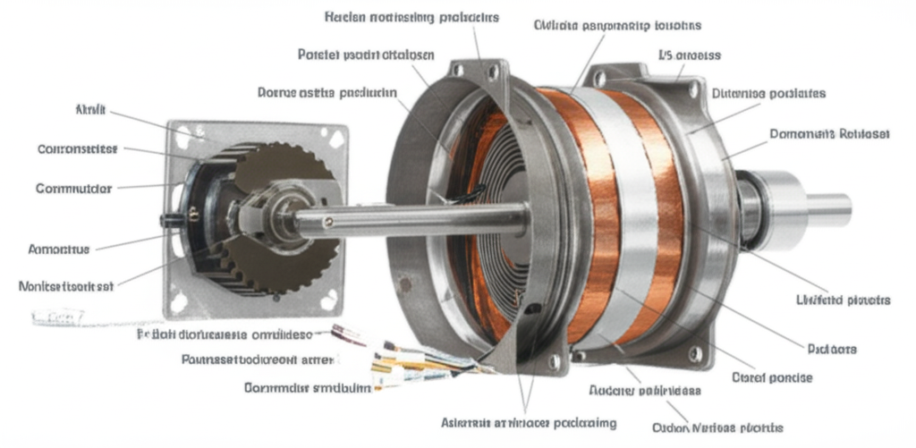
The armature is the part that spins inside the motor. It's made up of coils of wire wrapped around a core. When electricity flows through these wires in a magnetic field, it creates a force that makes the armature turn.

Field Magnets:
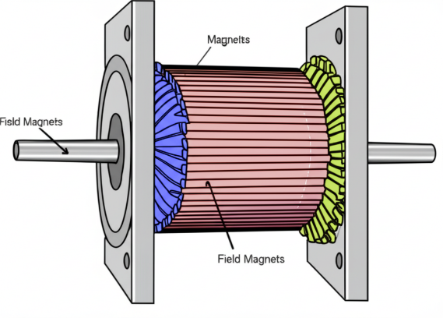
Field magnets create the magnetic field that the armature spins in. These can be permanent magnets (like the ones on your fridge) or electromagnets (coils of wire that become magnetic when electricity flows through them).

Armature Conductors:
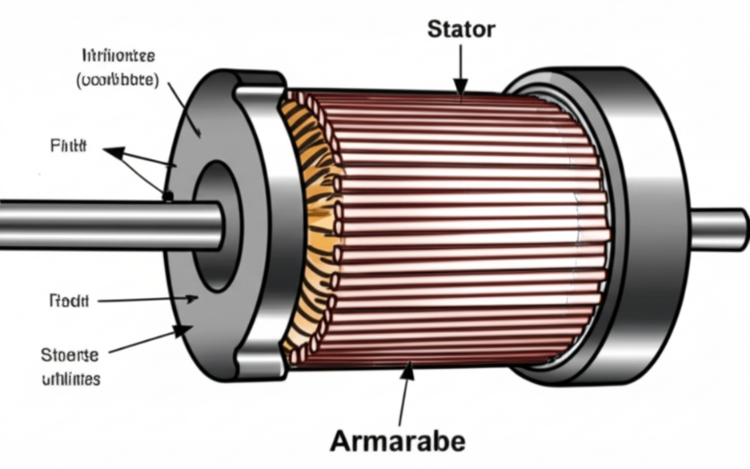
Armature conductors are the wires that carry the electricity within the armature. It's the force on these current-carrying wires in the magnetic field that makes the armature rotate.

Commutator:
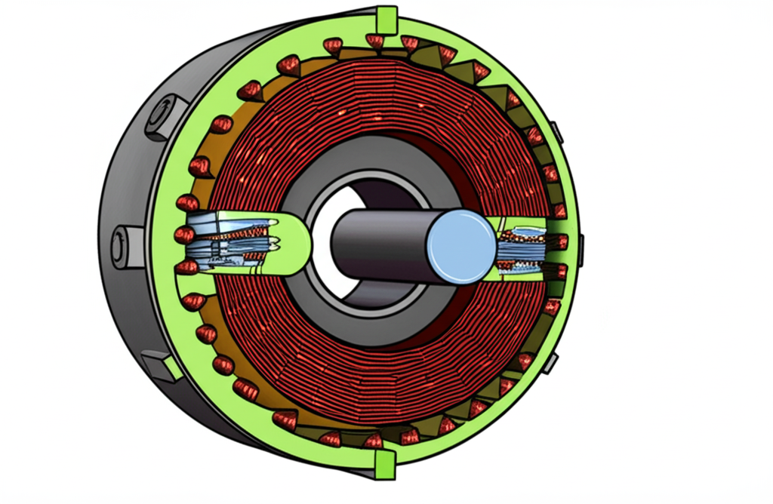
The commutator is a rotating switch connected to the armature. Its job is to reverse the direction of the electric current flowing through the armature coils as they spin. This ensures that the force on the armature always pushes it in the same direction, keeping it rotating.

Brushes:
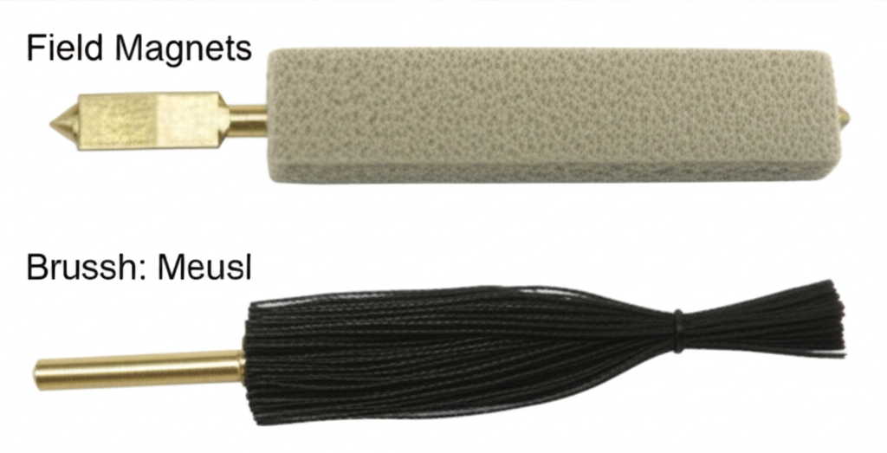
Brushes are stationary parts that press against the commutator. They are usually made of carbon. Brushes conduct electricity from the outside power source to the rotating commutator and then to the armature windings.

Stator (or Yoke/Frame):
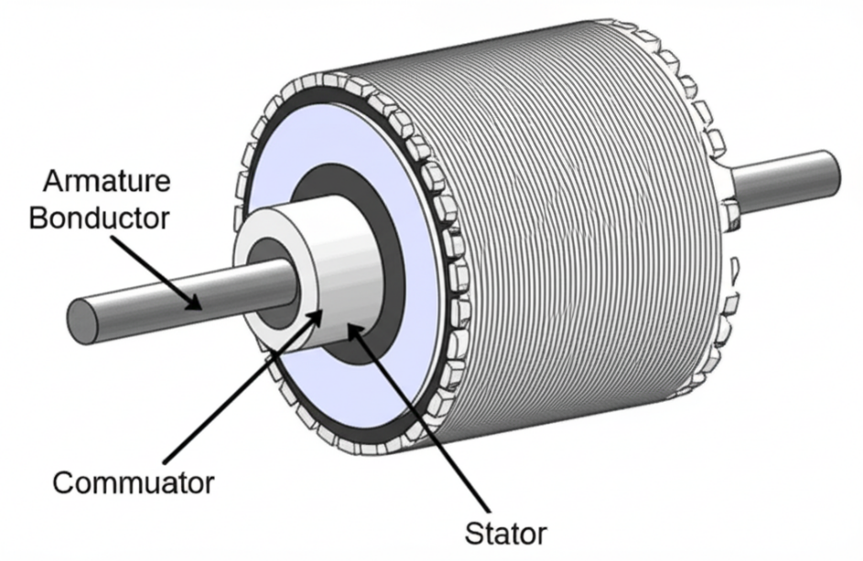
The stator is the outer, non-moving part of the motor. It provides structural support for the other components and often houses the field magnets. Think of it as the motor's body.

Shaft:
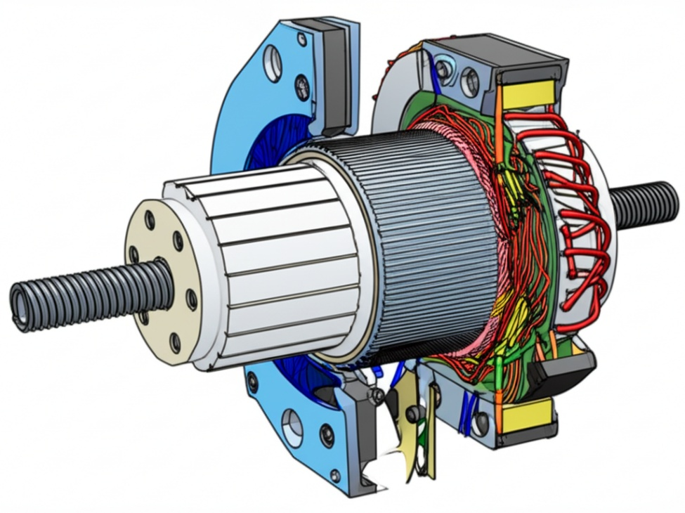
The shaft is the rod that sticks out from the motor. The armature and commutator are attached to it. As the armature spins, the shaft also spins, and this is what transfers the motor's turning power to whatever it's connected to.

Bearings:
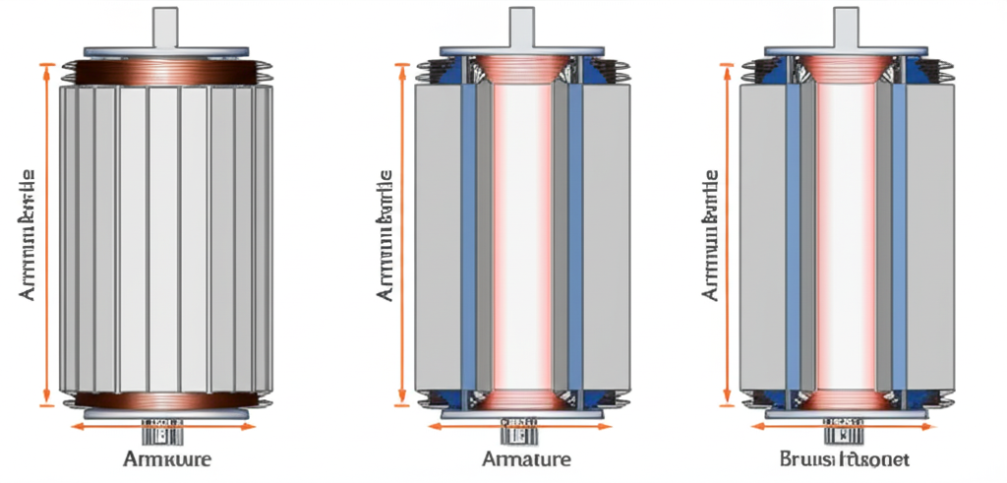
Bearings are used to support the spinning shaft, allowing it to rotate smoothly with as little friction as possible. They are usually located at both ends of the shaft.
End Shields/End Plates:
End shields, also called end plates, are the covers on the ends of the motor. They help to hold the bearings in place and protect the internal parts of the motor from damage and dust.
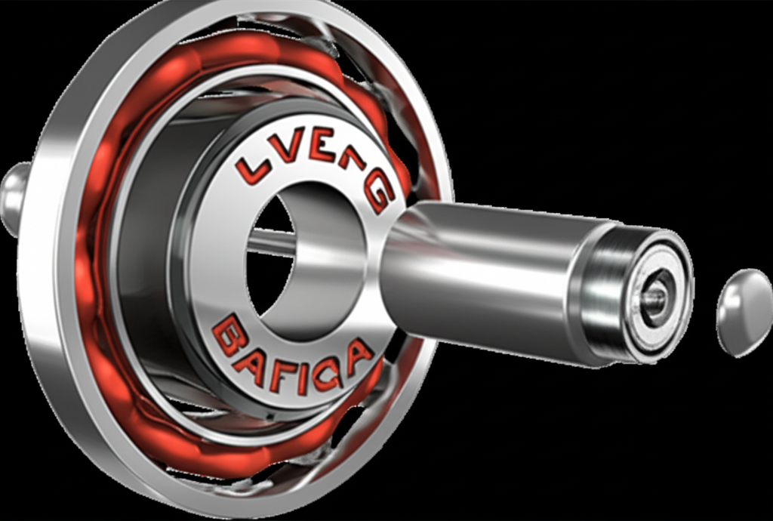

Handout: CAD Modeling for DC Motors
This handout shows the main parts of a DC electric motor used in some electric vehicles. You will see what each part looks like and learn why it is important for making the motor turn. The instructions included will tell you which shapes and tools in your CAD program to use when building models of these different motor parts. By following these steps and looking at the 3D models, you can understand how a motor is built and how it works to move a car.
1. Stator:
- What it is: The stationary outer part of the motor.
- Importance: It houses the field magnets (either permanent magnets or electromagnets created by field windings) that produce the magnetic field the rotor interacts with to generate torque.
- CAD Modeling: The stator can be modeled as a cylindrical housing with clearly defined magnetic poles (either as separate blocks for permanent magnets or with slots and raised sections to represent where the field windings would be). Highlighting the air gap between the stator and the rotor is also important.
2. Rotor (or Armature):
- What it is: The rotating inner part of the motor.
- Importance: It contains the windings (coils of wire) that carry the current and generate their own magnetic field, which interacts with the stator's field to produce rotation.
- CAD Modeling: The rotor can be modeled as a cylindrical core with slots or grooves on its surface to represent where the windings are placed. The windings themselves can be simplified as thicker lines or rectangular blocks within these slots.
3. Commutator (for Brushed DC Motors):
- What it is: A segmented cylindrical ring attached to the rotor shaft.
- Importance: It acts as a rotary electrical switch, reversing the direction of current flow in the rotor windings every half rotation. This ensures that the torque produced always acts in the same direction, allowing for continuous rotation.
- CAD Modeling: The commutator can be modeled as a series of copper segments separated by insulating material, all mounted on the rotor shaft. The connections from the rotor windings to these segments can also be shown in a simplified manner.
4. Brushes (for Brushed DC Motors):
- What it is: Conductive blocks (typically made of carbon) that are held in contact with the commutator.
- Importance: They provide the electrical connection between the stationary power source and the rotating commutator, allowing current to flow into the rotor windings.
- CAD Modeling: The brushes can be modeled as simple rectangular blocks held in brush holders that press against the outer surface of the commutator.

5. Motor Housing/Casing:
- What it is: The outer structure that encloses and protects the internal components of the motor.
- Importance: Provides structural support, protects against dust and moisture, and can aid in heat dissipation.
- CAD Modeling: This can be a more complex shape depending on the motor design but is generally an outer shell with mounting features and possibly cooling fins.
When creating CAD models it is beneficial to:
- Use clear and distinct colors for different components.
- Create exploded views to show how the parts fit together.
- Simplify complex features like the actual wire windings. Represent them conceptually.
- Focus on the overall shape and interaction of the key components.
- Include labels for each part in the CAD model or accompanying drawings.
Why these parts are important for EVs:
While modern EVs predominantly use Brushless DC (BLDC) motors, understanding the principles of brushed DC motors provides a foundational knowledge of how electrical energy is converted to mechanical motion using magnetic fields. The core concepts of a stator, rotor, and the interaction of magnetic fields remain relevant. Even in BLDC motors (which might be a more advanced topic for CAD modeling), you still have a stator with windings and a rotor with permanent magnets, although the commutation is electronic rather than mechanical.
By modeling these fundamental parts, high schoolers can gain a valuable visual and spatial understanding of how DC motors work, which is a crucial concept in electric vehicle technology. They can then appreciate the advancements in BLDC motors that improve efficiency and reduce maintenance.

Assessment: CAD Modeling Grading Rubric
Category | Excellent (4 Points) | Good (3 points) | Fair (2 Points) | Needs Improvement (1 Point)
Stator Model Accuracy | Stator accurately represents the key features (housing, poles/slots) with clear form. | Stator generally represents key features, but some minor details may be missing or unclear. | Stator shows a basic shape but lacks important features or has significant inaccuracies. | Stator model is poorly represented or missing key elements.
Rotor Model Accuracy | Rotor accurately represents the core and space for windings with clear form. | Rotor generally represents the core and winding space, but some minor details are unclear. | Rotor shows a basic shape but lacks representation of winding space or has inaccuracies. | Rotor model is poorly represented or missing key elements.
Overall Assembly/Relationship | Parts are correctly oriented and show a clear relationship to each other. | Parts are mostly correctly oriented, and the general relationship is understandable. | Parts are somewhat misaligned, and the relationship between them is unclear. | Parts are significantly misaligned, and the overall assembly is difficult to understand.
Use of CAD Tools | Demonstrates effective and appropriate use of CAD tools to create the model. | Shows adequate use of CAD tools, but some techniques could be improved. | Shows basic use of CAD tools, but the model is simplistic or poorly constructed. | Demonstrates limited or incorrect use of CAD tools.
Participation | All group members actively participate and contribute equally to the project. | Most group members participate and contribute. | Some group members participate, but contributions are uneven. | Few or no group members participate.

Notes:

Total Score: _________________ / 20

Assessment: AC Motors Research Tables Grading Rubric
Category | Excellent (4 Points) | Good (3 points) | Fair (2 Points) | Needs Imprvmnt (1 Point)
Completeness of Motor Types & Basic Info | Table includes all three motor types (DC, Induction, Synchronous) with accurate power source description for each. | Table includes all three motor types with mostly accurate power source descriptions. | Table includes all three motor types, but power source descriptions may be missing or inaccurate for some. | Table is missing one or more motor types, and/or power source descriptions are largely inaccurate or missing.
Working Principle & Speed Control | Clear, concise, and accurate explanations of working principles and speed control methods for all motor types. Demonstrates strong understanding. | Explains working principles and speed control methods for all motor types accurately; but lack clarity or conciseness. | Explains working principles and speed control methods for most motor types, but explanations may be incomplete, inaccurate, or difficult to understand. | Explains working principles and speed control methods for only one or two motor types, with significant inaccuracies or lack of clarity.
Key Characteristics | Accurately and completely describes starting torque and efficiency levels for all motor types. | Describes starting torque and efficiency levels for all motor types, with minor inaccuracies. | Describes starting torque and efficiency levels for most motor types, with some inaccuracies or omissions. | Describes starting torque and efficiency levels for only one or two motor types, with significant inaccuracies.
Practical Considerations | Accurately and completely describes cost considerations and maintenance needs for all motor types. | Describes cost considerations and maintenance needs for all motor types, with minor inaccuracies. | Describes cost considerations and maintenance needs for most motor types, with some inaccuracies or omissions. | Describes cost considerations and maintenance needs for only one or two motor types, with significant inaccuracies.
Applications, Advantages, & Disadvantages | Provides complete and accurate list of typical applications; clearly outlines multiple advantages/ disadvantages for all motor types. | Provides a list of typical applications; outlines advantages and disadvantages for all motor types, with minor inaccuracies or omissions. | Provides a list of typical applications and outlines advantages and disadvantages for most motor types, but some points may be unclear, inaccurate, or missing. | Provides a list of typical applications and outlines advantages and disadvantages for only one or two motor types, with significant inaccuracies or omissions.

Total Score: _________________ / 20

